**Year 1 Knowledge Organiser: Spring 2**



**Religion and World Views**

This unit will cover What questions does the story of creation make us ask? This unit is an important opportunity for pupils to begin to think openly, respectfully and critically about religion and belief

**DT**

Pupils will identify someone in their **home environment** that they would like to send a card or message to, and will design and make a card with moving words or pictures. In focused practical tasks, pupils will make simple linkages like levers.

.

**History**

Our history topic this half term is history of transport. This topic is an introduction to the development of transport by land, sea, air and space and the roles of key individuals.

**Science**

In this topic we will be consolidating and reviewing everything we have learnt so far throughout the year. We will be exploring all three topics we have covered so far to ensure children are secure and understand what we have studied up to now.

**Reading**

The class author focus for Year 1, is Hena Khan. We are currently reading several of her texts in our class read aloud, such as Night of the moon and Under my Hijab. Our daily Phonics reading sessions focus on reading the sounds we already know, reading fluently and developing our comprehension. At the end of the day during our class read alouds this is where we focus on voice choice.

**PHSE**

The children will be looking at what we can do with money.

**PE**

PE will be every Tuesday with Mr Wood, please ensure your child is bringing in the correct PE kit. They will be focusing on net and wall team building.

**Music**

This half term we will continue using charanga, our unit is ‘Round and round’. Children will be practicing and performing the song In Round and Round by Joanna Mangona.

**Maths**

This half term we will be consolidating our knowledge of our number bonds to 7. We will continue to look at place value within 50 and then begin looking at length and height and volume and mass. These units will allow pupils to have lots of practical lessons to really consolidate their learning and knowledge.

**Writing**

**Writing to entertain** – Pupils will apply their learning to creating their own unique story inspired by existing fairy tale characters, settings and plots.

**Writing to persuade** – We will apply their knowledge to creating a persuasive poster encouraging a chosen audience to visit their school or local area.

**How to help at home…**

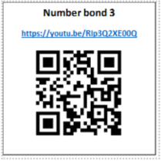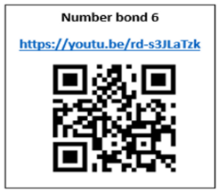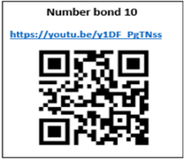**

**History**

In order to support your child in history this half term, you could go on a method of public transport together and see if your child could tell you how this method of transport has changed overtime, see if they could create a timeline of how transport has changed.

**Science**

In order to support your child in science this half term, you can visit this website

<https://www.stem.org.uk/resources/community/collection/12725/year-1-everyday-materials>

<https://www.bbc.co.uk/bitesize/topics/zkvv4wx>

There are quizzes and different activities to work through.

**Maths**

Please ensure that your child is practicing their number bonds at home, we practice these in class everyday, your extra support at home will secure this knowledge further. You can also watch the videos below by using the QR codes, which will help you to understand how we teach number bonds at school.

**Writing**

Before your child starts to write their own creative sentences and stories, learning about a range of different stories can help them develop their imagination and creativity. By reading traditional stories together, your child will explore imaginative settings, events and characters.

They’ll also start to learn the different ways that stories work as well as devices that writers use to create their tales. To help your child become more familiar with stories, you could try sequencing and retelling events from the stories together or use role-play to act out different parts of the tales.

**Reading**

You can support your child at home by ensuring that you are reading with them daily and logging their reading on learningwithparents.com through either a comment, picture, or voice recording! At school we have lots of books that your child can borrow and take home, these can be exchanged as many times as you would like!